SIMATS ENGINEERING
ASSESSMENT TOOL 2

NAME:SIVARANGJENII B
REG.NO:192521375

COURSE NAME: CSA07 COURSE CODE: Computer Networks

COURSE OUTCOME COVERED
CO1: Apply the functions of OSI layer in enabling reliable data transmission across networks.
(BL2, BL3)
Assessment Tool Weightage: 30%

Annexure A
CONCEPT MAPPING
1. A partially completed concept map is given below:

Application → Presentation → ______ → Transport → Network → ______ → Physical.
Analyze the missing layers and explain how their functions are essential for reliable
communication.
2. Construct a concept map linking data units (Segment, Packet, Frame, Bits) with their
respective OSI layers and analyze how transformation of data units supports
transmission.

3.Given the concept map:
DataLink→MACAddress→LocalDelivery
Network → IP Address → Global Delivery
Explain how these relationships ensure complete data delivery across networks.

4. A concept map shows:
ErrorControl
→DataLinkLayer→ErrorDetection
→ Transport Layer → Error Correction
Analyze how the interaction between these layers improves reliability in data
transmission.

5. Develop a concept map for web browsing using OSI layers and analyze how failure in
one layer affects the entire communication process.
6. A network issue is represented in the concept map:
Physical ✔ → Data Link ✔ → Network ✖ → Transport ✖ → Application ✖
Analyze the problem and explain how the concept map helps in troubleshooting.

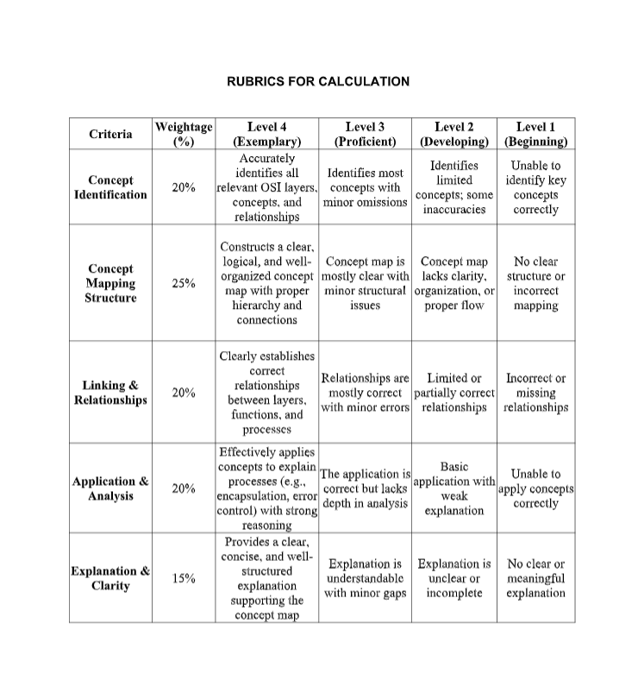
ANSWERS

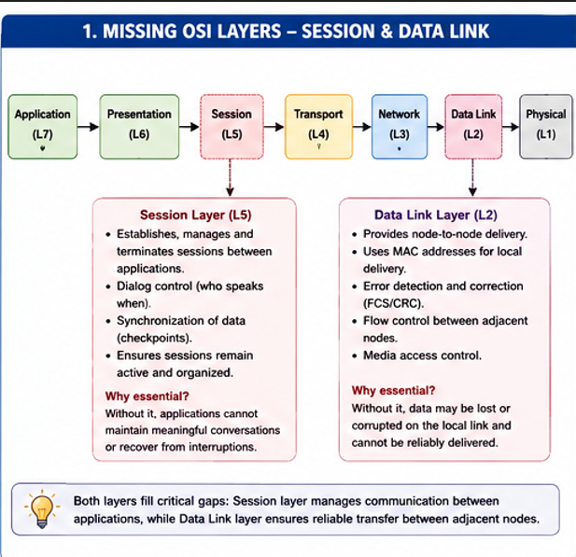
1.

2. 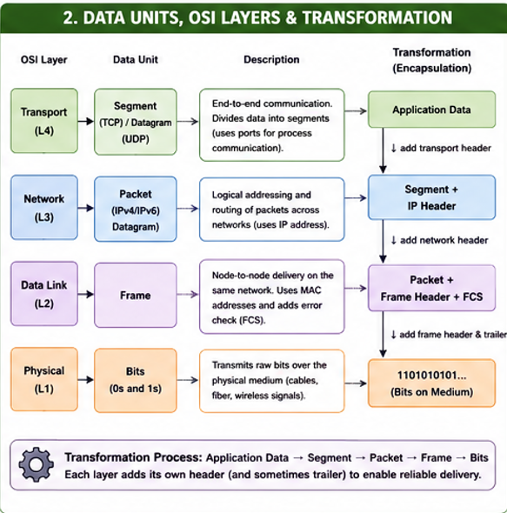

3. 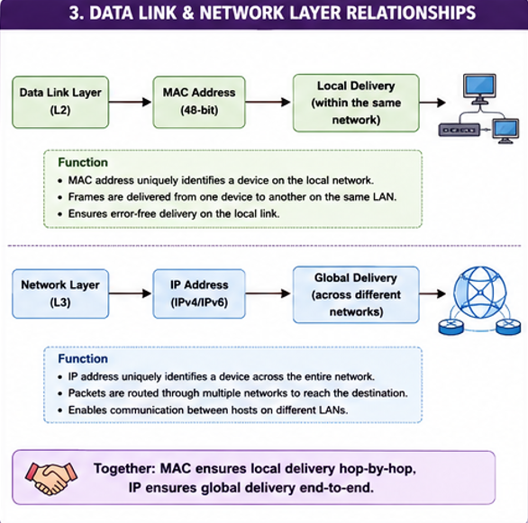

4. 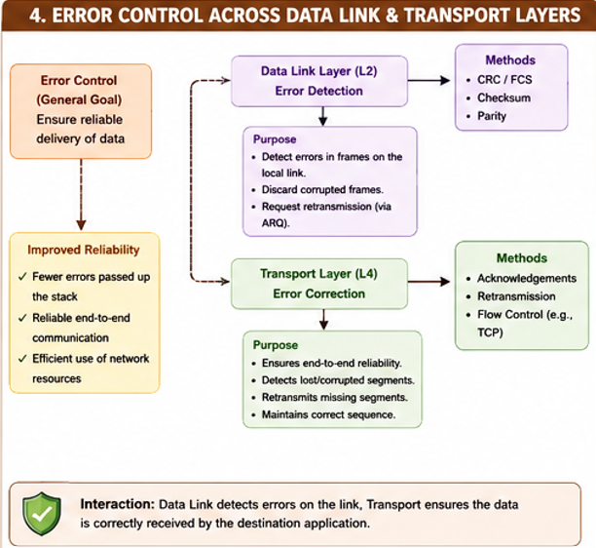

5. 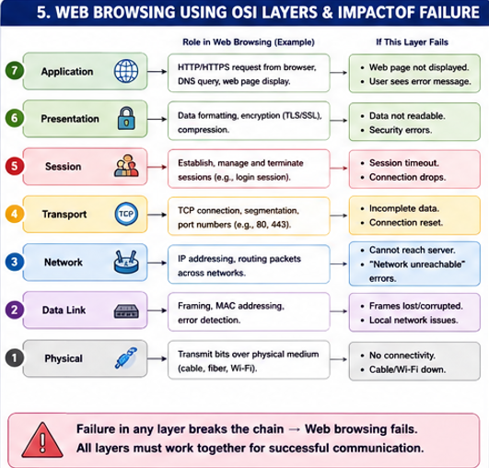
6. 